SIMATS ENGINEERING (SAVEETHA SCHOOL OF ENGINEERING)
Department of Computer Science and Engineering

ASSESSMENT TOOL 2 – Industry Problem Solving Task

Course Code: | CSA06 | Course Title: | Design and Analysis of Algorithms
CO Assessed: | CO4: Articulation (BL4, BL5) | Assessment: | Assessment Tool 2 – Industry Problem Solving Task
Weightage: | 20% of CIA | Total Marks: | 100
CO4 Statement: | Solve optimization problems using dynamic programming and greedy strategies.
Student Name: | V SANJANA | Reg. No.: | 192571005
Section / Batch: | 2025 | Date: | 22-08-2026

Instructions to Students
- Answer the following question. Total Marks: 100.
- Carefully analyze the given questions.
- Explain in detail with sample code if needed.
- Clearly identify all key issues.
- Provide a thorough analysis with validated results and performance evaluation.

Question Type | Focus Area | Questions
Industry Problem Solving Task | Focus on Solving optimization problems using dynamic programming and greedy strategies | Q1

SECTION A – Industry Problem Solving Task

Code of Conduct
I _V SANJANA(192571005)_ (Name / Reg No) certify that this submission is my original work and that I have adhered to the guidelines specified for this assessment. I understand that any violation of academic integrity rules will result in disciplinary action.
Signature of the Student: _________________________

RUBRICS FOR CALCULATION

Industry Problem Solving Task

Criteria | Weightage | Level 4 – Exemplary | Level 3 –  Proficient | Level 2 –  Developing | Level 1 –  Beginning
Understanding of  Industry Problem | 20% | Comprehensive understanding of  real-world problem and constraints | Good understanding with minor gaps in requirements | Basic understanding; some  requirements unclear | Poor understanding; misinterprets problem context
Application of  Engineering  Concepts | 25% | Applies advanced and relevant concepts  effectively to solve the problem | Applies appropriate  concepts with minor errors | Limited application of concepts | Incorrect or no application of concepts
Solution Design | 25% | Innovative, practical, and feasible solution  aligned with industry standards | Logical and feasible solution with minor gaps | Basic solution with limited feasibility | Unclear or impractical solution
Use of Tools | 15% | Effective use of modern tools,  technologies, and real  data | Appropriate use of tools with correct implementation | Limited or inconsistent use of tools | Minimal or incorrect use of tools
Analysis | 10% | Thorough analysis with validated results and performance evaluation | Good analysis with reasonable validation | Basic analysis with limited validation | Poor or no analysis
Professionalism | 5% | Highly professional, well-documented,  and clearly presented  work | Good documentation and presentation | Basic documentation with some gaps | Poor documentation and presentation

Marks Evaluation:
Criteria | Wt. | Level 4 –  Exemplary | Level 3 –  Proficient | Level 2 –  Developing | Level 1 –  Beginning
Understanding of Industry Problem | 20%
Application of Engineering Concepts | 25%
Solution Design | 25%
Use of Tools | 15%
Analysis | 10%
Professionalism | 5%
Total Marks (100):

Faculty In-charge | Course Coordinator | Head of Department
Name: | Name: | Name:
Signature: _______________ | Signature: _______________ | Signature: _______________
Date: ___________________ | Date: ___________________ | Date: ___________________

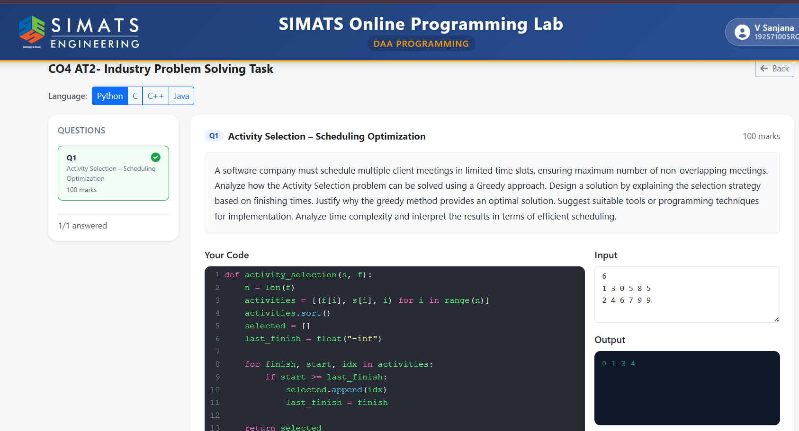

Activity Selection – Scheduling Optimization
Problem Statement
A software company needs to schedule several client meetings within limited available time slots. Since some meetings may overlap, the objective is to select the maximum number of non-overlapping meetings. This can be efficiently solved using the Greedy Activity Selection Algorithm.
Greedy Approach
The greedy strategy selects meetings based on their finish times. First, all meetings are sorted in increasing order of finishing time. The meeting that finishes earliest is selected first because it leaves maximum remaining time for other meetings. After selecting a meeting, the next meeting is chosen only when its starting time is greater than or equal to the finishing time of the previously selected meeting. This process continues until all meetings are checked.
Time and Space Complexity
Sorting n meetings according to finish time requires:
O(n log n)
After sorting, every activity is checked once:
O(n)
Therefore, the overall:
Time Complexity = O(n log n)
If activities are already sorted by finish time:
Time Complexity = O(n)
The algorithm requires only a few additional variables:
Auxiliary Space Complexity = O(1)
Space Complexity = O(n) if selected activities are stored separately.
Result and Scheduling Interpretation
The Greedy Activity Selection algorithm successfully maximizes the number of non-overlapping client meetings. By always selecting the earliest-finishing compatible meeting, the company can make better use of available time slots, reduce scheduling conflicts, and improve resource utilization. Hence, the greedy method is a simple, fast, and optimal solution for standard activity scheduling problems.

